An Asymptotic High-Frequency Solution for Scattering from an Electrically Wide Triangular Cavity

Mehdi Bozorgi1

1Department of Electrical Engineering, Faculty of Engineering, Arak University, Arak, Iran

Corresponding author: Mehdi Bozorgi (email: M-Bozorgi@araku.ac.ir).

ABSTRACT An asymptotic solution based on high-frequency approximations is proposed to determine the scattered waves from a wide empty isosceles triangular cavity. The modal method based on cylindrical wavefunction expansion with the physical optics technique is used to find analytical expressions for the unknown expansion coefficients and significantly improve the time efficiency of calculations. Some assumptions and simplifications are made to reduce the complexity of the problem while still being accurate for wide triangular cavities. Comparisons are achieved to illustrate the validity and time efficiency of the suggested solution.

INDEX TERMS Asymptotic solution, Triangular cavity, Modal technique, Electromagnetic wave scattering.

I. INTRODUCTION

**I**

n many applications, such as radar cross-section (RCS) reducer, non-destructive testing, and optical devices, scattering from cavities is a significant problem. Recently, corrugated structures, especially triangular groove gratings have been employed in optical instruments such as optical disk storages, spectroscopy, and wavelength-division multiplexer.

Lots of research studies have been done on scattering from rectangular cavities (U-shaped cavities) and consequently, various methods have been developed to improve the accuracy and computational efficiency of simulations [1-5]. There are cavities whose opening decreases with increasing depth and their shape can be considered as a triangle (V-shaped cavities). Due to the complexity of the analysis of scattered waves from triangular cavities, it has received less attention. In general, to simulate scattered waves from complicated cavities such as triangular cavities, full numerical methods such as the Method of Moments (MoM) and the finite element method (FEM) are used. In large structures, we often meet serious problems when using full numerical methods. In this case, we should increase the number of meshes, and therefore, the memory requirements and CPU-time extremely increase. The use of analytical methods can be a suitable solution for this problem.

There are a few approaches proposed for studying scattered waves from triangular cavities [6-8]. The Fourier transform technique in [6] has been suggested to analyze scattering from a periodic right triangular groove. Scattering from a large isosceles right triangle groove has been investigated in [7] using the modal technique that used trigonometric wave function to expand the fields inside and outside the groove. The tangential fields are matched at the cavity opening and a system of linear equations is constructed. In another study in [8], the modal expansion method in cylindrical coordinate was applied to an arbitrary isosceles triangular groove, successfully. Because of the accuracy and the convenient implementation, modal methods are often employed to study the scattering problems in complicated configurations.

However, the main problem with this semi-analytic technique is that we need to solve an enormous system of linear equations for a wide cavity. It is also noted that the computational complexity of the semi-analytic method proposed in [8] was of order $N^{3}$ and we had to solve a linear system of order *N* to determine the coefficients of modal series. In optical applications, we generally encounter the problem of electrically large cavities. In these structures, using full numerical methods such as FEM and MoM is too time-consuming. Fast methods including analytical solutions can provide an appropriate tool for the design problems as well as develop trained systems to evaluate electrically large structures.

In this paper for a wide empty triangular cavity, an asymptotic solution based on modal technique based on the cylindrical wavefunction is developed. Unlike the previous methods that obtain expansion coefficients by truncating infinite series and solving a system of linear equations, in this work, we attempt to find analytical expressions for computing the expansion coefficients to reduce the computation time. First, we introduce a simplification technique and replace the half-space of the above cavity with a semi-infinite wedge waveguide. Although this replacement is appropriate for a wide triangular cavity, it makes unacceptably errors for a narrow one. Next, the tangential fields in two different regions are expanded in terms of a series of cylindrical wave functions with unknown coefficients. Finally, the unknown coefficients are obtained analytically by satisfying the boundary conditions at an arc-shaped boundary in the presence of a physical optic current. For this purpose, the expressions are all represented in the same cylindrical coordinate system using the Graf’s addition theorem. The solution is applied to several wide cavities and will then be validated numerically using MoM. To demonstrate the time efficiency of this method, we measured the simulation times for three different methods and then compared them with each other. The results of this study illustrated that this solution for wide triangular cavities can considerably reduce the simulation time, while it is also accurate.

II.  STATEMENT OF PROBLEM AND SOLUTION

The wide empty isosceles triangular cavity considered in this study has been shown in Fig. 1.

$$ε_{0},μ_{0}$$

$$H_{z}^{i},E_{z}^{i}$$

Region1

$$y'$$

$$φ^{i}$$

**PEC**

`

**PEC**

$$O'$$

$$d$$

$$ε_{0},μ_{0}$$

Region2

$$y$$

$$x$$

$$h$$

$$α$$

$$x'$$

*W/2*

$$O$$

$$z$$

$$z'$$

**FIGURE 1.** Geometry of a wide empty triangular cavity in PEC plane

**PEC**

$$S$$

$$J_{op}$$

Region1

**PEC wall**

$$y'$$

**PEC wall**

$$O'$$

Region2

$$x'$$

$$α$$

$$y$$

$$x$$

$$O$$

**FIGURE 2.** Replacing upper half-space with a semi-infinite wide wedge waveguide with PEC walls

This figure depicts an arbitrary triangular cavity of width $W$, length of legs $d$, height $h$, and vertex angle $α$ placed in an infinite Perfect Electric Conductor (PEC) plane. The excitation of the model is a normalized TE and TM plane waves with an incident angle $φ^{i}$ expressed in the $x'o'y'(r^{'}φ^{'})$-coordinate system as given in the following

$H_{z}^{i},E_{z}^{i}=\hat{z}e^{ik_{0}r^{'}\cos{(φ^{'}-φ^{i})}} φ^{i}∈(0,π)$ (1)

where $k_{0}$ is the free space propagation constant. Because of the two separate analyzed regions, two different cylindrical coordinate systems $(x,y)$ and $(x',y')$ are employed where the origin of $xy(rφ)$-coordinate system is fixed at the point $o$, While the origin of $x'y'(r^{'}φ^{'})$-coordinate system is set at the point $o'$ is the middle of the cavity opening. Inside region 2, the tangential electric and magnetic fields $E_{z}^{(2)}$, $H_{φ}^{(2)}$ (for TM mode), $E_{φ}^{(2)}$, and $H_{z}^{(2)}$ (for TE mode) can be taken as the sum of the cylindrical wave functions as [11]

TE mode:

$H_{z}^{(2)}\left(r,φ\right)=\sum_{m=0}^{+∞}{b_{m }J_{ν}\left(k_{0}r\right)\cos{(υφ)} }$ (2)

$E_{φ}^{(2)}\left(r,φ\right)=(j/ωε_{0})\sum_{m=0}^{+∞}{b_{m }{J'}_{ν}\left(k_{0}r\right)\cos{(υφ)} }$ (3)

TM mode:

$E_{z}^{(2)}\left(r,φ\right)=\sum_{m=1}^{+∞}{b_{m }J_{ν}\left(k_{0}r\right)\sin{(υφ)} }$ (4)

$H_{φ}^{(2)}\left(r,φ\right)=(1/jωμ_{0})\sum_{m=1}^{+∞}{b_{m }{J'}_{ν}\left(k_{0}r\right)\sin{(υφ)} }$ (5)

where $J_{m}\left(.\right)$ and ${J'}_{m}\left(.\right)$ denote the Bessel function of the first kind of order $m$ and the differential forms of related function, respectively. Also, $b_{m }$ are the unknown coefficients and $ν$ is equal $mπ/α$. To derive the tangential fields in the outer region (region 1), we employ a replacement technique like the method reported in [3] and substitute the upper half-space with a semi-infinite wedge waveguide with PEC walls as shown in Fig. 2. This replacement yields to obtain simple equations and consequently, we no longer have to solve complex singular integral equations. In this case, the fields in region 1 can be expanded on the basis functions of a semi-infinite wedge waveguide as [11].

TE mode:

$H_{z}^{(1)}\left(r,φ\right)=\sum_{m=0}^{+∞}{a_{m }H_{ν}\left(k_{0}r\right)\cos{(υφ)} }$ (6)

$E_{φ}^{(1)}\left(r,φ\right)=(\frac{j}{ωε_{0}})\sum_{m=0}^{+∞}{a_{m }{H'}_{ν}\left(k_{0}r\right)\cos{(υφ)} }$ (7)

TM mode:

$E_{z}^{(1)}\left(r,φ\right)=\sum_{m=1}^{+∞}{a_{m }H_{ν}\left(k_{0}r\right)\sin{(υφ)} }$ (8)

$H_{φ}^{(1)}\left(r,φ\right)=(\frac{1}{jωμ_{0}})\sum_{m=1}^{+∞}{a_{m }{H'}_{ν}\left(k_{0}r\right)\sin{(υφ)} }$ (9)

where $H_{m}\left(.\right)$ and ${H'}_{m}\left(.\right)$ are the Hankel function of the second kind with order *m* and the differential forms of related function. The tangential fields $H_{z,φ}^{(1,2)}$ and $E_{z,φ}^{(1,2)}$ should satisfy the boundary conditions on the arc-shaped surface $S$:

${TM mode: E}_{z}^{(1)}-E_{z}^{\left(2\right)}=0$, $H_{φ}^{(1)}-H_{φ}^{\left(2\right)}=J_{eq}$ on $S$ (10)

${TE mode: E}_{φ}^{(1)}-E_{φ}^{\left(2\right)}=0$, $H_{z}^{(1)}-H_{z}^{\left(2\right)}=J_{eq}$ on $S$ (11)

where the current $J_{eq}$ is the equivalent electric current induced by the magnetic field on the surface $S$. As the opening of the cavity becomes very wide (*W* increases), the equivalent electric current $J_{eq}$ is asymptotic to the physical optics current $J_{op}$ shown in Fig. 2 and given as

$${ \hat{J}}_{eq}≅{\hat{J}}_{op}=\hat{ρ'}×\left(H^{i} \hat{z'},\hat{φ'}+H^{r} \hat{z'},\hat{φ'}\right) on S$$

$W→∞$ (12)

In which $H^{i}$ and $H^{r}$ are the incident and reflected magnetic fields, respectively. As seen in (12), the physical optics current $J_{op}$ consists of $φ$-component for TE mode and $z$-component for TM mode. Then, through applying the boundary conditions (10)-(11) on the surface $S (r=d)$, the following equations for both modes are obtained as

TE mode:

$\left(\frac{j}{ωε_{0}}\right)\sum_{m=0}^{+∞}{a_{m }{H^{'}}_{ν}\left(k_{0}d\right)\cos\left(υφ\right) }=(\frac{j}{ωε_{0}})\sum_{m=0}^{+∞}{b_{m }{J'}_{ν}\left(k_{0}d\right)\cos{(υφ)} }$ (13)

$\sum_{m=0}^{+∞}{a_{m }H_{ν}\left(k_{0}d\right)\cos\left(υφ\right)}-$

$\sum_{m=0}^{+∞}{b_{m }J_{ν}\left(k_{0}d\right)\cos{(υφ)}=J_{op}}$ (14)

TM mode:

$\sum_{m=1}^{+∞}{b_{m }J_{ν}\left(k_{0}d\right)\sin{(υφ)} }=\sum_{m=1}^{+∞}{a_{m }H_{ν}\left(k_{0}d\right)\sin{(υφ)} }$

(15)

$\left(\frac{1}{jωμ_{0}}\right)\sum_{m=0,1}^{+∞}{a_{m }{H^{'}}_{ν}\left(k_{0}d\right)\sin\left(υφ\right) }-\left(\frac{1}{jωμ_{0}}\right)\sum_{m=0,1}^{+∞}{b_{m }{J^{'}}_{ν}\left(k_{0}d\right)\sin\left(υφ\right) }=J_{op}$ (16)

By multiply the equations (13) and (14) by $\cos{(υφ)}$ and (15) and (16) by $\cos{(kφ)}$ and integrating over the range [0*, $α$*], we have

TE mode:

$\left(\frac{j}{ωε_{0}}\right)a_{m }{H^{'}}_{ν}\left(k_{0}d\right)={(\frac{j}{ωε_{0}})b}_{m }{J'}_{ν}\left(k_{0}d\right)$ (17)

$a_{m }H_{ν}\left(k_{0}d\right)-b_{m }J_{ν}\left(k_{0}d\right)=\frac{2}{α}\int_{0}^{α}{J_{op}\cos{(υφ)dφ}}$ (18)

TM mode:

$b_{m }J_{ν}\left(k_{0}d\right)=a_{m }H_{ν}\left(k_{0}d\right)$ (19)

$\left(\frac{1}{jωμ_{0}}\right)a_{m }{H^{'}}_{ν}\left(k_{0}d\right)-\left(\frac{1}{jωμ_{0}}\right)b_{m }{J^{'}}_{ν}\left(k_{0}d\right)=\frac{2}{α}\int_{0}^{α}{J_{op}\sin\left(υφ\right)}dφ$ (20)

Substituting (17) into (18) and (19) into (20), respectively, the unknown coefficients $b_{m }$ for both modes can be determined analytically as

TE mode:

$b_{m }=\frac{I_{m} {H^{'}}_{ν}\left(k_{0}d\right)}{{J^{'}}_{ν}\left(k_{0}d\right)H_{ν}\left(k_{0}d\right)-J_{ν}\left(k_{0}d\right){H^{'}}_{ν}\left(k_{0}d\right)}$ (21)

TM mode:

$b_{m }=\frac{jωμ_{0}I_{m} H_{ν}\left(k_{0}d\right)}{{J^{'}}_{ν}\left(k_{0}d\right)H_{ν}\left(k_{0}d\right)-J_{ν}\left(k_{0}d\right){H^{'}}_{ν}\left(k_{0}d\right)}$ (22)

Where $I_{m}$ are defined for each mode as

$I_{m}=\frac{2}{α}\left\{\begin{aligned}\int_{0}^{α}{J_{op}\cos{(υφ)dφ}}, TE Mode \\ \int_{0}^{α}{J_{op}\sin\left(υφ\right)dφ}, &TM mode\end{aligned}\right.$ (23)

Once these unknown coefficients $a_{m }$ and $b_{m }$ are obtained, the far-zone scattered ﬁelds can be calculated from the corresponding radiation integrals using the tangential electric ﬁelds on the surface $S$ [9]. To obtain the coefficients $I_{m}$ we should first determine physical optics current $J_{op}$ on the surface $S.$ In the $x'o'y'(r^{'}φ^{'})$-coordinate system, the physical optics current on $S$ is given as

${\hat{J}}_{op}=\hat{ρ'}×\left(H^{i} +H^{r} \right) on S$

$J_{op}=\left\{\begin{aligned}\sum_{m=0}^{+∞}{4i^{m} {\cos{(mφ^{i})}J}_{m}\left(k_{0}r^{'}\right) }\cos\left({mφ}^{'}\right) TE Mode \\ \sum_{m=1}^{+∞}{4i^{m} {\sin{({mφ}^{i})}J'}_{m}\left(k_{0}r^{'}\right) }\sin{({mφ}^{'})} TM Mode\end{aligned}\right.$

(24)

To transfer $J_{op}$ into $xoy(rφ)$-coordinate system, we employ the Graf’s addition theorem [10] as denoted in [8]. Thus we can write:

TE mode:

$J_{m}\left(k_{0}r^{'}\right)\cos{({mφ}^{'})}=\sum_{p=-∞ }^{+∞}{J_{m-p}\left(k_{0}h\right)J_{p}\left(k_{0}r\right)\cos\left(θ_{mp}(φ)\right)}$ (25)

TM mode:

$J_{m}\left(k_{0}r^{'}\right)\sin{({mφ}^{'})}=\sum_{p=-∞ }^{+∞}{J_{m-p}\left(k_{0}h\right)J_{p}\left(k_{0}r\right)\sin\left(θ_{mp}(φ)\right)}$ (26)

Where $θ_{mp}(φ)=m\frac{3π}{2}-p(φ+π+\frac{α}{2})$. Substituting (25) and (26) into (24), the coefficients $I_{m}$ can be calculated as:

$I_{m}=\sum_{m=0}^{+∞}{ 4i^{m} \sum_{p=-∞ }^{+∞}{{d_{mp} J}_{m-p}\left(k_{0}h\right).}}$

$\left\{\begin{aligned}J_{p}\left(k_{0}d\right)cos{(mφ^{i})} TE Mode \\ {J'}_{p}\left(k_{0}d\right)\sin{(mφ^{i})} TM Mode\end{aligned}\right.$

(27)

in which $d_{mp}$ is

$d_{mp}=\left\{\begin{aligned}\int_{0}^{α}{\cos\left(θ_{mp}(φ)\right)\cos\left(υφ\right)dφ TE Mode} \\ \int_{0}^{α}{\sin\left(θ_{mp}(φ)\right)\sin\left(υφ\right)dφ TM Mode}\end{aligned}\right.$ (28)

The integrals in (28) have an analytical solution [10]. Lastly, with sufficient accuracy, we can truncate the infinite series in (27) to finite numbers $M$ and $P$. The series of the Graf's addition theorem transformation (25) and (26) for $r>h cosθ_{mp}(φ)$ are convergent [10]. [12].

III.  RESULTS

Herein, we present some results obtained using the above procedure. These results are compared to the results obtained by the full numerical method MoM used in FEKO software. To validate the accuracy of this procedure, we plotted the electric fields $E_{z}$ and $E_{φ}$ for both modes at the incident angle ${ φ}^{i}={90}^{o}$ on the surface $S$ in Fig. 3. The specifications of the wide triangular cavity considered for this example are $W=8λ$, $α={120}^{o}$. As can be seen from Fig.3, the results obtained by this method are in good agreement with the numerical results which were calculated with MoM. The series (25), (26), and (27) with indices *m* and *p* were truncated and bounded from 0 to *M* and *−P* to +*P* terms, respectively. For this example, we set *M=34* and *P=120* to achieve a desired degree of accuracy. More terms of *M* and *P* are needed when the cavity width increases. We found the minimum truncated value *M* is greater than the argument of the Bessel function ${ k}_{0}d$. Also, our analysis shows, *P* of about *4M* is more than adequate.

The next example to consider is the back-scattering of the different incident plane-wave fields. Fig.4 exhibits the back-scattering of the triangular isosceles cavity of the previous example for both modes. Also, to compare results, we display the backscattering and bistatic echowidth patterns as a function of the angle of incidence and observation angle, simultaneously. The bistatic echowidths have been calculated at the observation angle ${ φ}^{o}=-φ^{i}$. As seen in Fig. 4, when the angle of incidence increases, the backscattering echowidth and the bistatic echowidth increase too. However, the backscattering echowidth is more sensitive to angle variation than the bistatic echowidth.

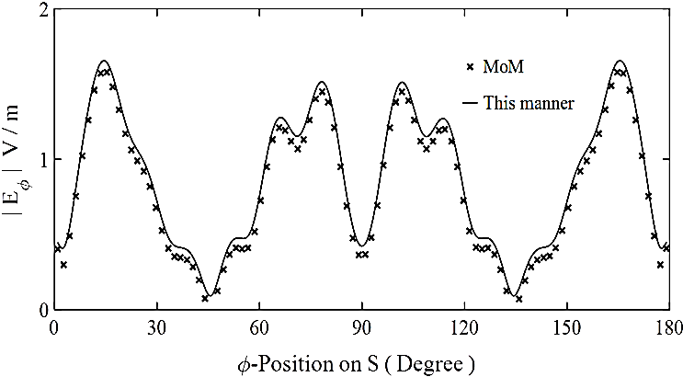

a) TE mode

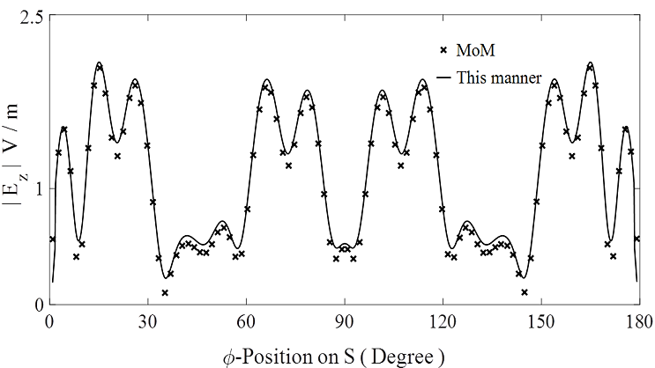

b) TM mode

**FIGURE 3.** the amplitude of the tangential electric fields $E_{z}$ and $E_{φ}$ on the surface $S$ as a function of $φ$-position for TE and TM modes with $ε_{r0}=ε_{r2}=1$ for a triangular isosceles cavity with $W=8λ$ and vertex angle $α={120}^{o}$ a) TE mode b) TM mode.

In another study, we investigated the accuracy and validation of the derived expressions for different values of the cavity width. For this purpose, we computed TE-backscattering echowidths of a triangular isosceles cavity for a wide range of cavity widths ( $W=0.5λ$ to $5λ$). These results were compared with the results obtained by MoM, Fig.5. Taking the MoM as the reference, when the cavity width decreases, the accuracy of the results decreases, too while for the cavity widths smaller than a wavelength, the results become invalid. However, we know that the asymptotic analytic formulas in the previous section were derived for a wide cavity.

To compare the computation efﬁciency of this solution with MoM and the semi-analytic method suggested in [10], we measured the simulation time for the cavity used in Fig. 3, Table I. A review of the results in Table I demonstrates that this solution is very faster than all numerical methods, including MoM and the semi-analytic method presented in [8] that needs to solve a linear system of order *N* . It should be however noted that full numerical methods such as MoM can be applied to cavities of arbitrary shapes and complex structures. In FEKO software, we simulated a 2-D triangular cavity by an infinite 3-D triangular cavity with one dimension Periodic Boundary Condition. To make the model run faster in the analysis, the body surfaces partially mesh through two local mesh sizes. The local mesh sizes on the PEC planes and the cavity surfaces were chosen 0.16 λ and 0.08 λ, respectively. The number of meshes and memory usage in this simulation were 24560 and 1000MB, respectively.



1. TE mode



(b) TM mode

**FIGURE 4.** Comparison of the backscattering and bistatic echowidth for a triangular isosceles cavity with $W=8λ$ and vertex angle $α={120}^{o}$ a) TE mode b) TM mode.

It is noted that the solution of the problem presented in this report can be employed to develop proper tools for the design of the triangular grating configurations used in various applications such as optics applications.

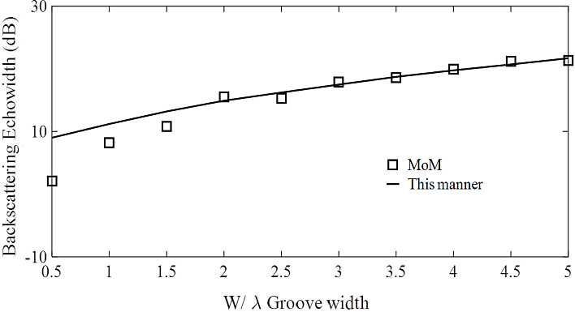

**FIGURE 5.** TE-Backscattering echowidth of the air-filled the triangular isosceles cavity $ε_{0}=ε_{2 }$ and $μ_{0}=μ_{2}$) at normal incidence for the different cavity widths (W=0.5λ to 5λ).

**TABLE I.** The simulation times of the different methods for computing the backscattering echowidth of the cavity described below Fig.4

(Resources: CPU: 2.4 GHz Core 2Quad, RAM: 8GB, Operating system: WNDOWS 64-bit)

|  |  |  |  |
| --- | --- | --- | --- |
| $$α={120}^{o}$$ | Mode expansion suggested in [8] | MoM | This method |
| $$W=8λ$$ | 4.13s | 26 Min | 3 ms |

IV. CONCLUSION

In this work, we introduced an analytic solution for scattering by electrically wide triangular isosceles cavity to compensate for the disadvantage of numerical methods is time-consuming. To simplify expressions and avoid encountering complex singular integrals, some appropriate approximations were used for a wide cavity. We consider a physical optics current on an auxiliary arc-shaped border and substitute the upper half-space with a semi-infinite wedge waveguide. Then, the tangential fields were expanded in terms of a series of cylindrical wave functions with unknown coefficients. The mode-by-mode ﬁeld matching on the auxiliary border and using the Graf’s addition theorem, the unknown coefficients were determined analytically. The derived expressions were used to compute the echowidth of some wide grooves to demonstrate the validity of the solution technique. The analytic solution allows a more effective computational performance for electrically large triangular isosceles cavities.

REFERENCES

1. K. Barkashli and J. L. Volakis, “TE scattering by a two-dimensional groove in a ground plane using higher-order boundary conditions,”IEEE Trans. Antennas Propag., vol. AP-38, no. 10, pp. 1421–1428,Sep. 1990.
2. T.J.Park and H.J.Eom, "An analysis of transverse electric scattering from a rectangular channel in a conducting plane" Radio Sci. Vol.28, pp 663-673, 1993.
3. M. A. Morgan, “Mode expansion solution for scattering by a material filled rectangular groove,” Progr. Electromagn.Res., vol. PIER 18,1998.
4. Cho, Y. H., "TM plane-wave scattering from finite rectangular grooves in a conducting plane using overlapping T-block method," IEEE Trans. Antennas Propagat., Vol. 54, No. 2, 746-749, 2006.
5. Chen, Yanli, Xue Jiang, Jun Lai and Peijun Li. “A fast algorithm for the electromagnetic scattering from a large rectangular cavity in three dimensions.” J. Comput. Phys. 437 (2021): 110331.
6. M. A. Basha, S. K. Chaudhuri, S. Safavi-Naein “A Fourier Expansion Solution to Plane Wave Scattering from Multiple Isosceles Right Triangle Grooves in Perfect Conducting Plane,” Photonic Applications in Devices and Communication Systems, Vol. 5970, Oct. 2005
7. M. Bozorgi, “A Mode-Matching Solution for Scattering from a Large Isosceles Right Triangle Groove in PEC Plane, ” *ADVANCED ELECTROMAGNETICS*, vol. 8, no. 5, pp. 37-43, Dec. 2019
8. M. Bozorgi, "A Modal Solution for Scattering by an Arbitrary Isosceles Triangular Groove," in IEEE Transactions on Antennas and Propagation, vol. 68, no. 12, pp. 8255-8259, Dec. 2020.
9. C. A. Balanis, Advanced Engineering Electromagnetics. United States of America: John Wiley and Sons, 1989.
10. M. Abramowitz and I. A. Stegun, Handbook of Mathematical Functions: with Formulas, Graphs, and Mathematical Tables (Dover Publications, 1965).
11. R. F. Harrington, “Time-Harmonic Electromagnetic Fields,” McGraw-Hill, New York, 1961, p. 127.
12. Julius Adams Stratton, Electromagnetic Theory, (McGraw‐Hill Book Company, Inc., New York, London, 1941), p. 568